
RACE | GLCL XC Round 1 Glebelands
HOST | Caerleon Running Club
VENUE | Glebelands, St Julians, Newport, NP19 7HF WTW ///excuse.brick.just  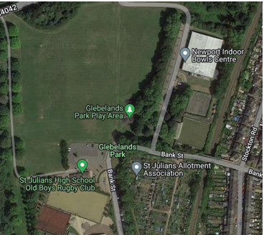
DATE | 19/10/2025
CONTACT DETAILS | Phil Cummings  phil.n.cummings@gmail.com
TIMETABLE | GLCL Race briefing 10.50  GLCL Race start time 11.00

PARKING

Car parking at the Newport Indoor Bowls Centre is extremely limited.
everyone is encouraged to car share as much as possible. Car park marshals will guide you into available spaces or into the overflow car park on arrival. If on-site parking fills up, you should park in the residential area surrounding Bank Street NP19 7HF. Please do this sensibly and sympathetically to residents.

TOILETS

Toilet facilities will be available at Newport Indoor Bowls Centre. If you wish to use these, you will be required to remove your footwear. There will be a marshal on the door ensuring this rule is adhered to. Please respect the request of the Bowls Club by doing this. Runners are also reminded that the Glebelands is a public space and should be used with consideration for other park users. Please don't jeopardise future races or our relationship with the local community by ignoring this request.

COURSE

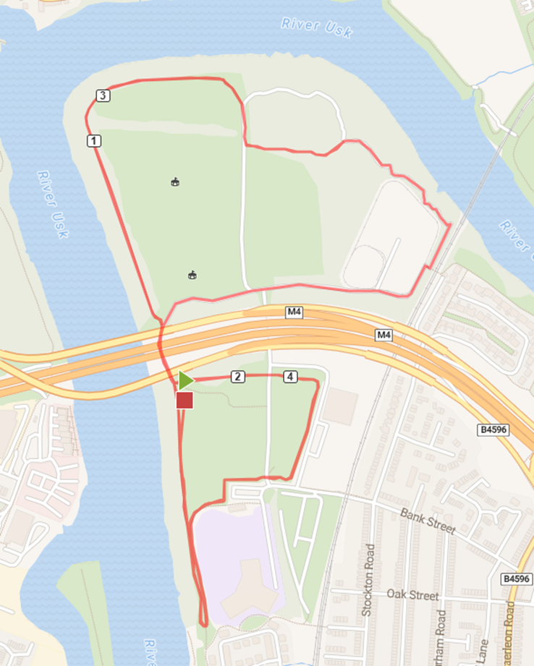

The course is approximately 4.60 miles long, with negligible climbing. It is a fast, flat, open course. The race is composed of two big loops (2 miles each), and one small loop (1 mile).

We advise that spikes are not to be worn due to some of the sections being not suitable for spikes.

FIRST AID

First aid will be provided by St. John Ambulance

RISK ASSESSMENT

Risk Assessment: Caerleon Running Club Glebelands XC - 19th October 2025

An appropriate Risk Assessment has been carried out. The course is likely to be muddy, slippery, wet, and exposed to the elements. You are advised to wear appropriate clothing and footwear for the conditions. There are are a number of areas where the path is very muddy, waterlogged and uneven. Runners should also be aware of a small tree trunk hurdle about 200m into the wooded section and various sections where there is limited headroom. The section of the wooded area parallel to the rail line should only be used for passing under exceptional circumstances. Please adopt suitable running etiquette particularly in this area.

List of Hazards | Recommendations to Minimise Risk | Action Taken
Course – Route is mostly flat. Approx. 250 metres of woodland. Grassed areas will be muddy, slippy and rutted due to other users. Evidence of some areas of anti-social activities in the woods. Some running on tarmac footpath. Some passing in narrow stretches. | Course will be marked-up with red/white tape and plastic posts. Full reconnaissance of the course will be undertaken in hours leading up to the race start time. Any hazards will be marked-up, removed or avoided.
Structures – Will avoid encroachment of course onto any marked playing fields. Woodland area has over-hanging branches and tree roots. | Some coppicing will be undertaken, if needed, in advance of the race.
Communications – Good visibility out on the course. Will have a group of marshals in touch by mobile phone, if necessary. | Approximately 25 fully-briefed marshals out on the course for the duration of the race. Will test mobile connectivity, but many marshals will be within ear-shot of each other.
Officials – Start and finish area, approx. 25 ‘turning points’. | See above. All officials will wear hi-viz. There will be appropriate signage.
First Aid | St Johns booked. Will have an ambulance based in the main car park. May also have one on the limits of the course. Will host pre-race briefing.
Car Parking – Should have fairly unhindered use of car parking, with overflow car park arrangements in place. | Acquired use of extra overflow car park (disused tennis court). Should accommodate 40-50 vehicles. Will have a car park team of three to oversee. Will message all participating clubs in advance to ask them to car-share due to limited parking opportunities.
Other facilities | Will have use of toilet facilities in the Indoor Bowls Club. Will ‘police’ use and access to the club, to ensure no one treads mud into the building. Clubs will be fore-warned.

UKA PERMIT

TBC

OFFICIALS

Race referee – Mike Heare

OTHER INFO

The start is a short walk from the main car park, adjacent to the M4 flyover. You are
advised to leave your kit either in your vehicle or in your club area. Please do not
leave kit at the start area. There will be plenty of available space for clubs to set up
club areas.

The club areas will be located opposite to the finishing straight. Please move to this
area when you finish, where it will be possible to cheer your teammates in. Please do
not use the course to cool down once you have finished.

RACE NUMBER / TIMING CHIPS

No number/chip = no result for you (don't start without one)

Wear the number most recently allocated - if you use an old one you find at home and it's not currently registered to you, you will not appear in the results

Please make sure you do not hold your hand over your number/chip when you cross the finish line - hold arms to side or above your head. You may not get registered by the system and the backup video at the finish will not record your number.

Please do not get close to the timing equipment (finish) once you've been through the finish once. Repeated 'pings' slow down the results system

Please do not take unused chips (from runners who are not running) close to the finish.... otherwise those not attending will appear in the results.

Full details can be found here on the GLCL Website - Entry / Registration Section

HEADPHONES

In accordance with UKA Rule 240 S 5, the wearing of headphones, or similar devices, is not permitted in this race. Non-compliance will result in the disqualification of the athlete and if deemed necessary a points penalty against the offending club.

CODE OF CONDUCT

Please adhere to the Code of Conduct at all times. Full details can be found here on the GLCL Website - Rules

COMPETITION RULES

Full details can be found here on the GLCL Website - Rules

